**HLT WEEK12 – To do Library Database**

**Library Data base Created**

**Created Table for books**

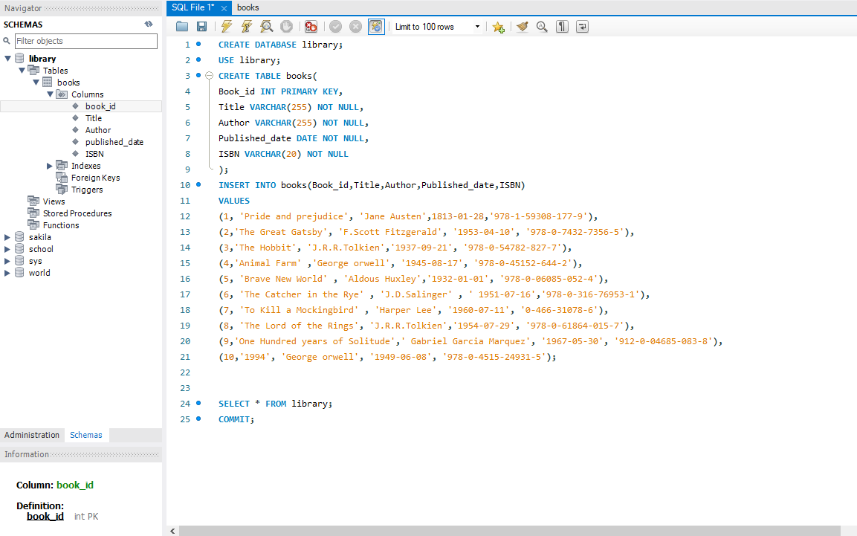

Continuation with results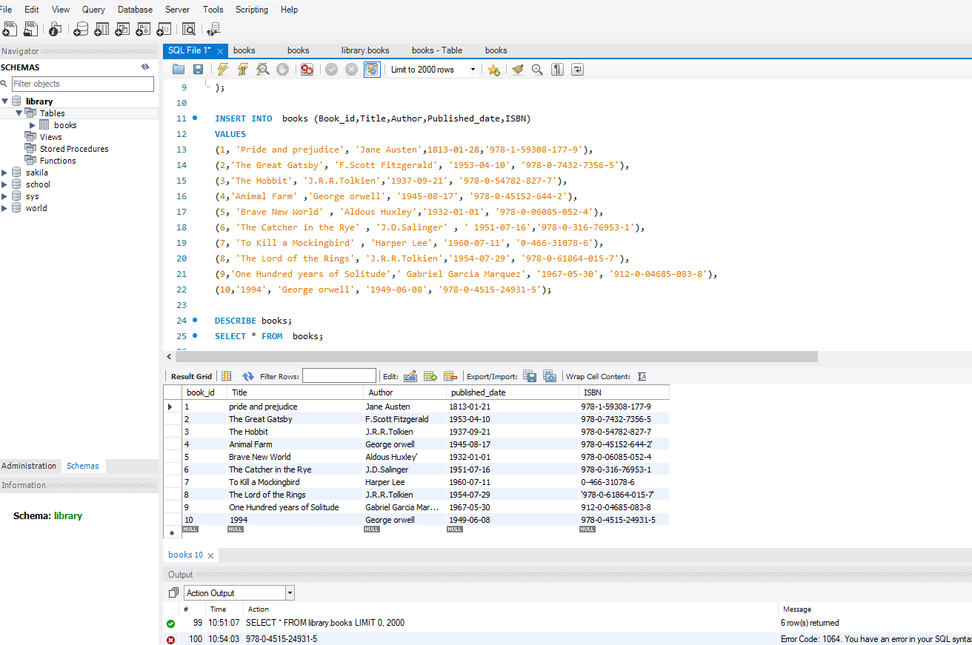

**Created table for Users**

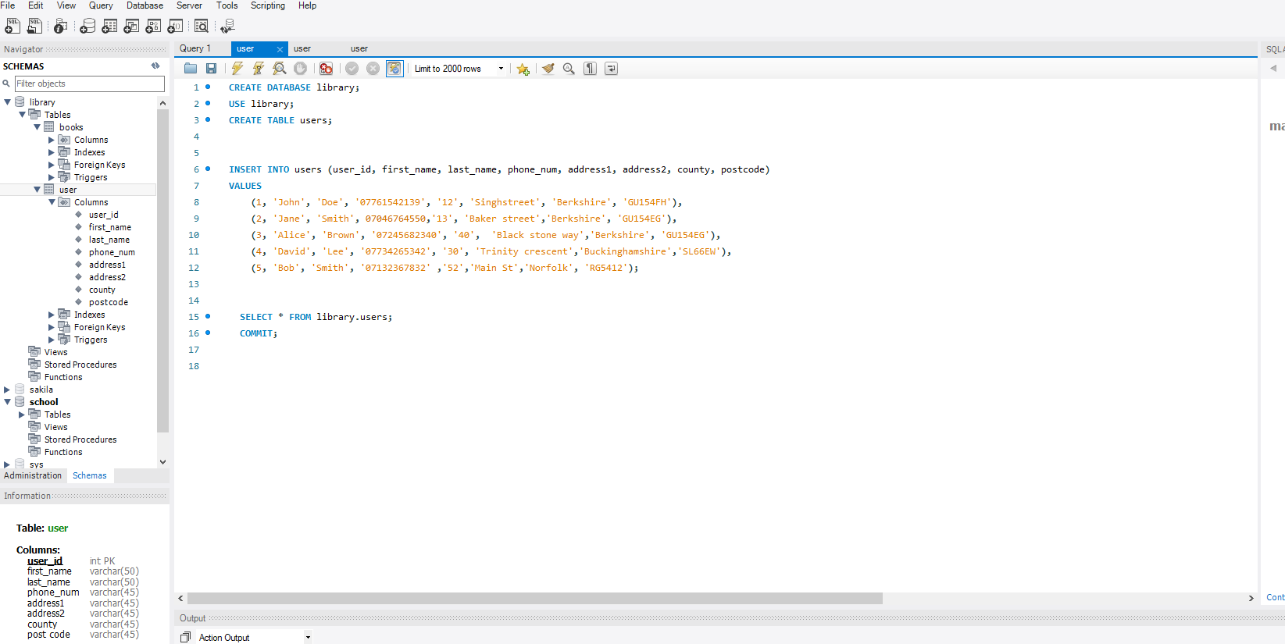

Continuation of User table

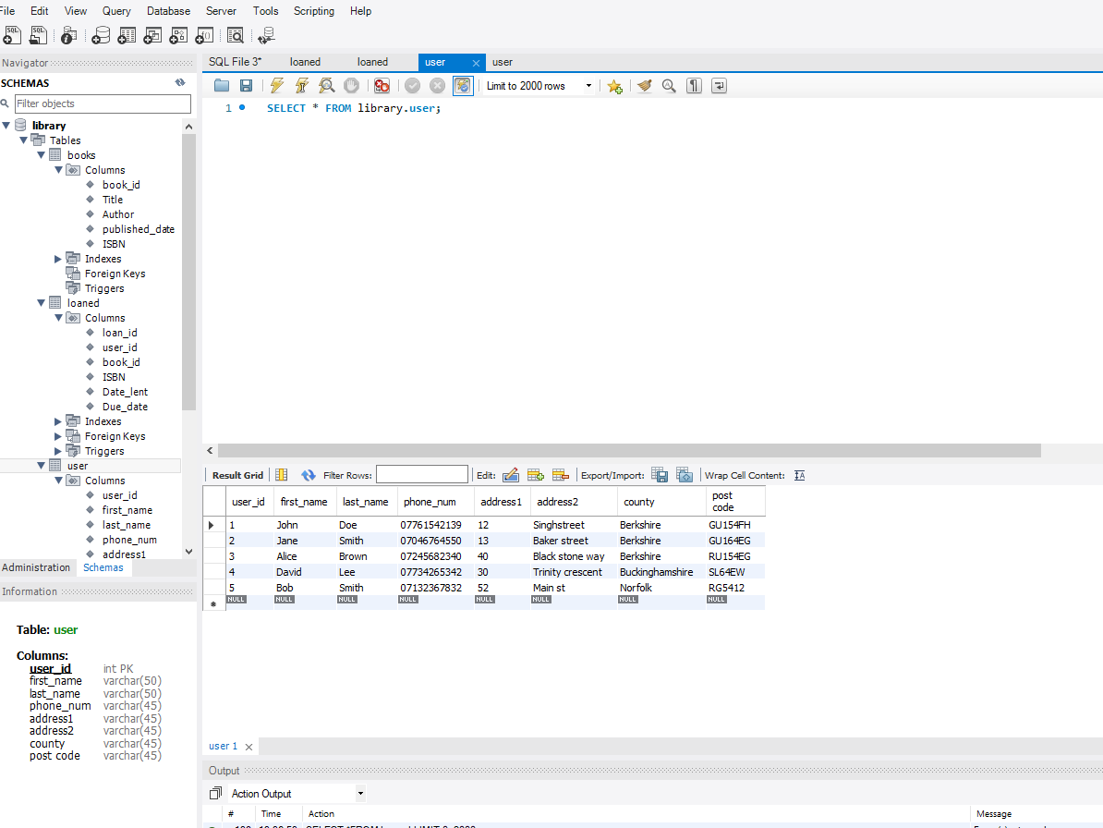

**Created table for Loaned**

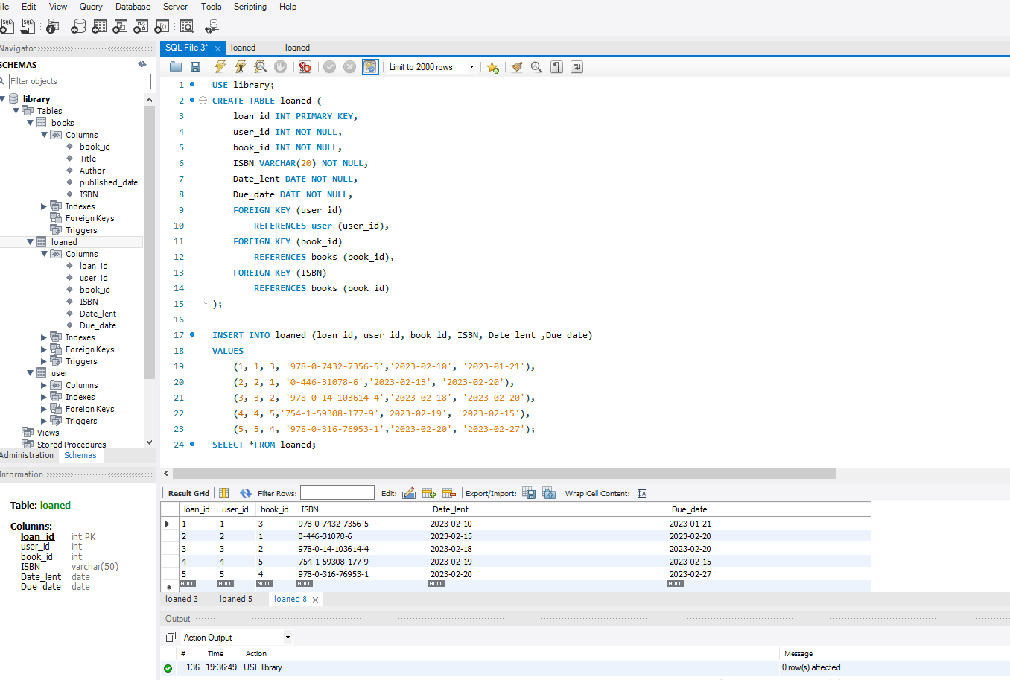

**SQL Queries**

**All Users**

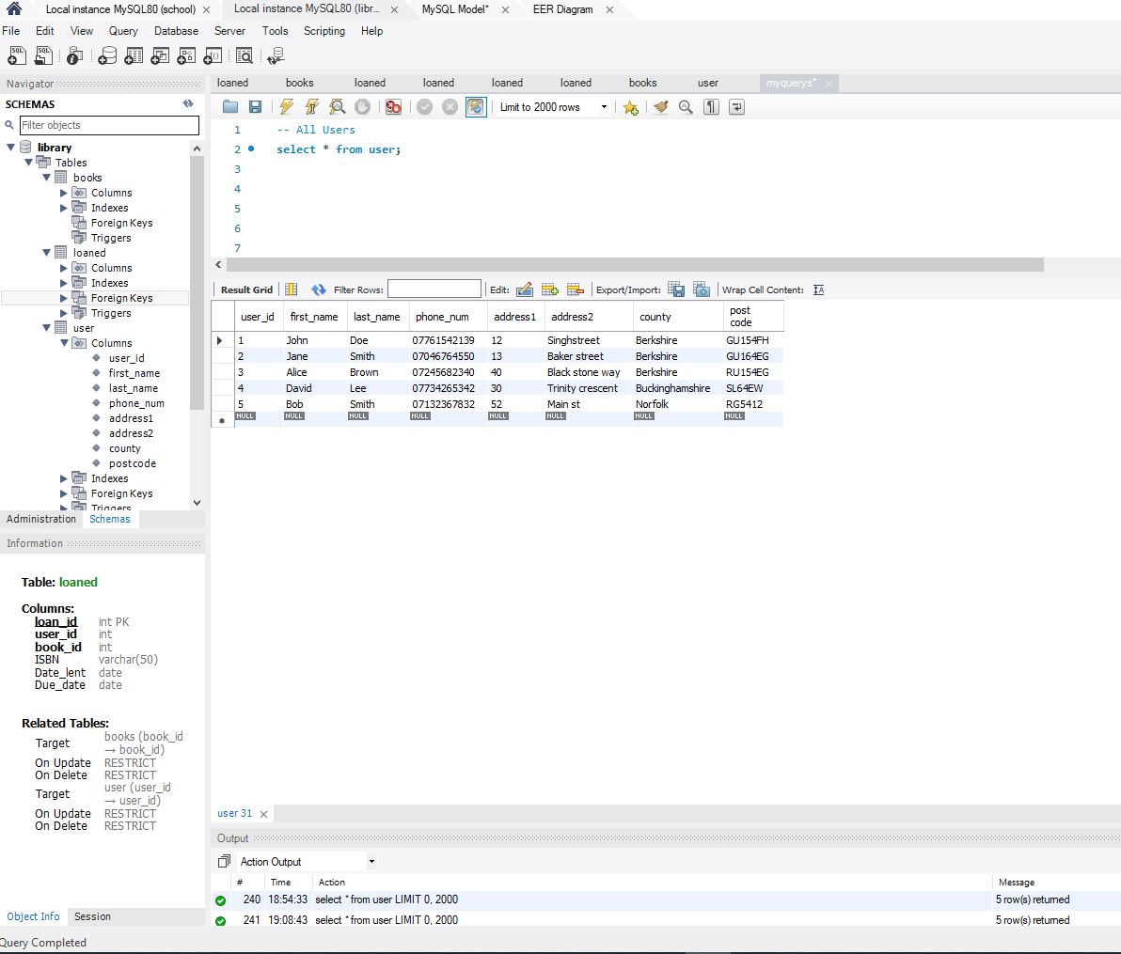

**All Books**

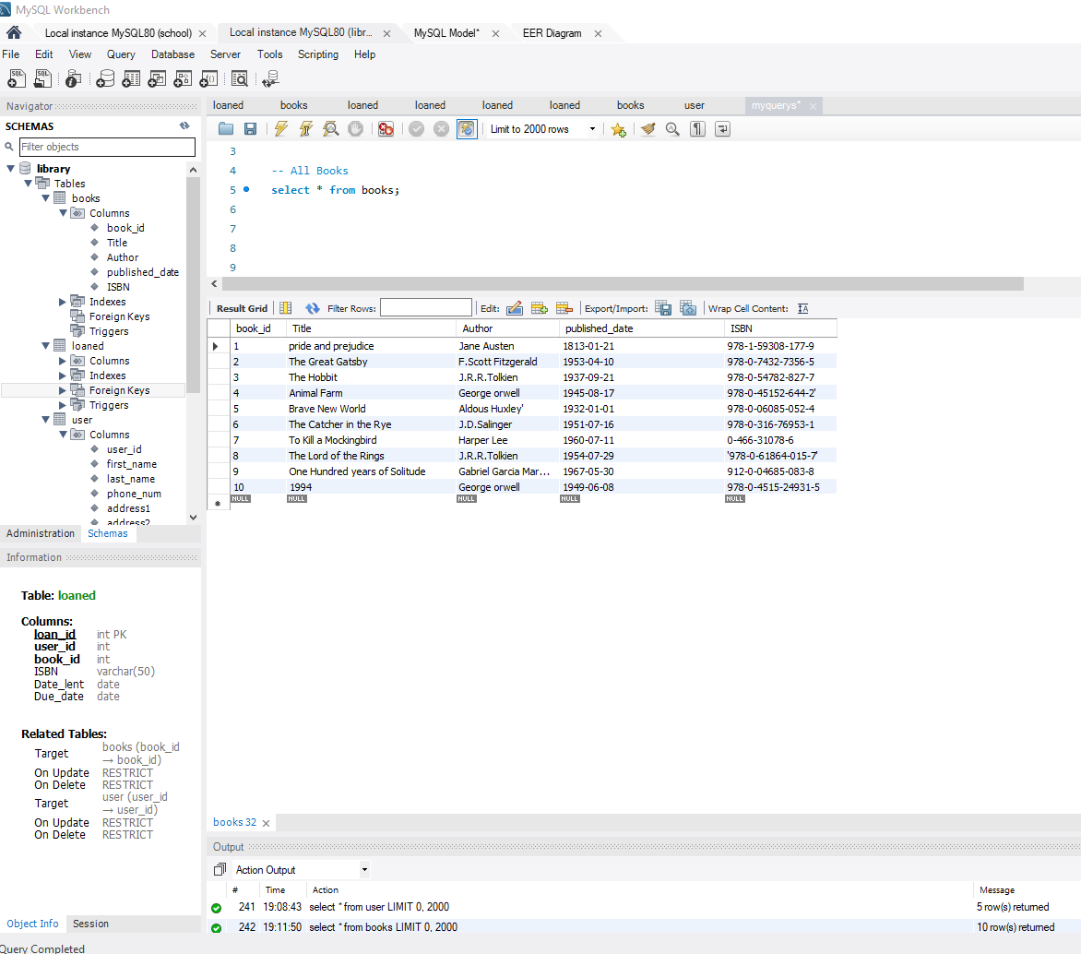

**All Users that have loaned a book**

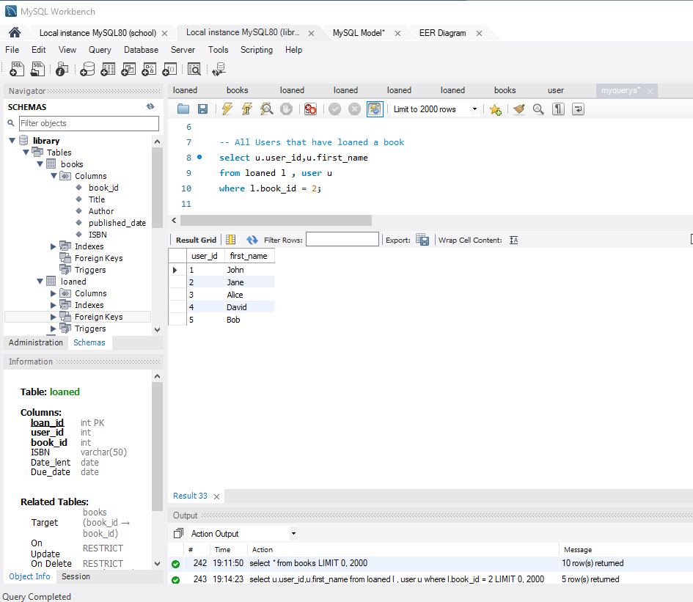

**All books loaned by a user**

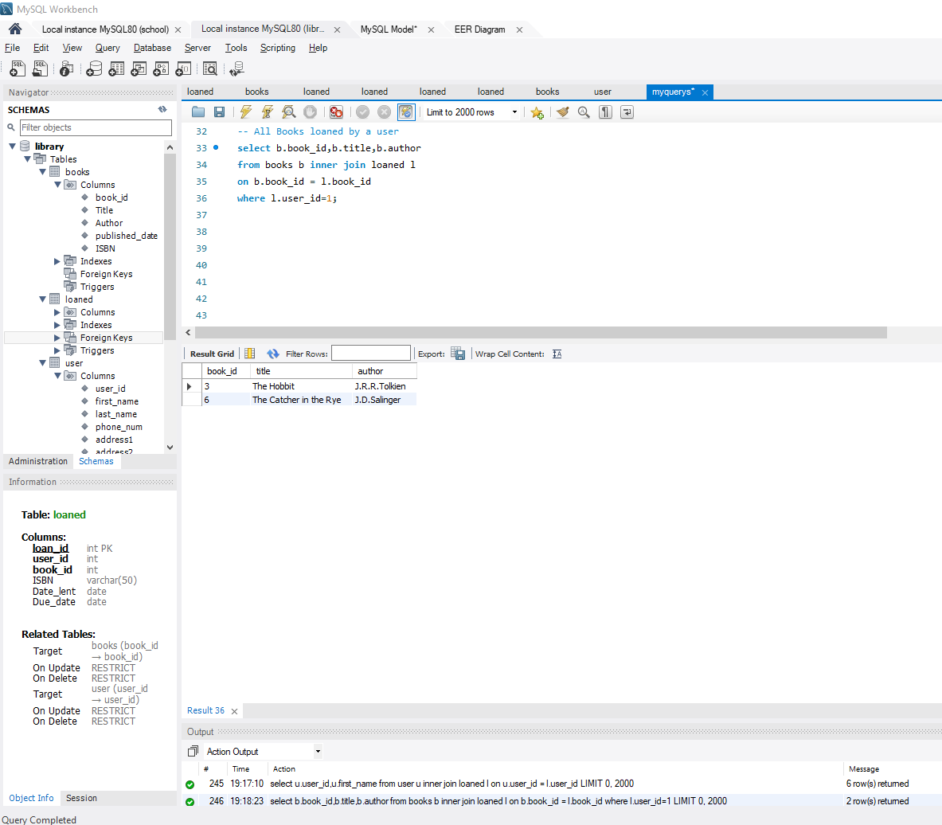

**All Users loaned all books – Combining 3 and 4**

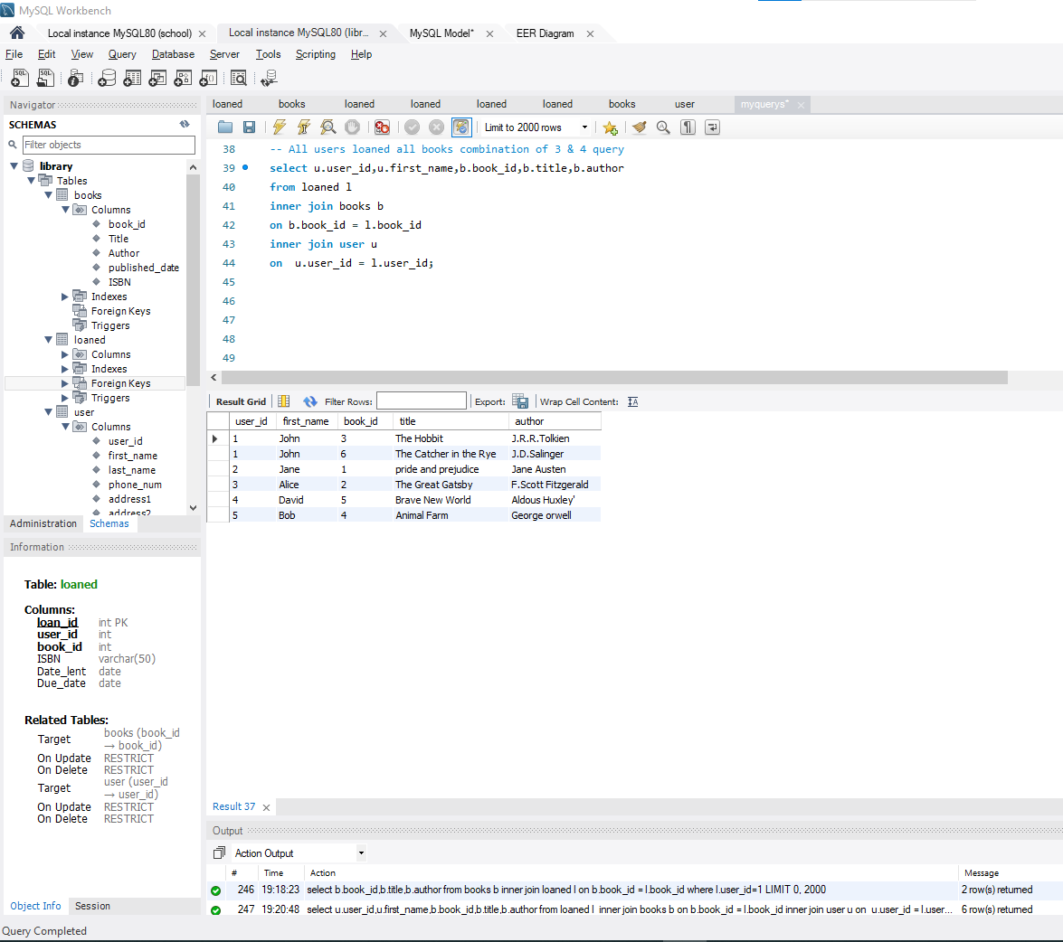

**All books overdue showing the user who has it, the book title & author and the date it was due**

